WORKSHEET SQL 2

Q1 to Q13 have only one correct answer. Choose the correct option to answer your question.
- Which of the following constraint requires that there should not be duplicate entries?
A) No Duplicity
B) Different
C) Null
D) Unique
Answer: D(Unique)

- Which of the following constraint allows null values in a column?
  - Primary key
B) Empty Value
C) Null
D) None of them
Answer: D(None of Them)

- Which of the following statements are true regarding Primary Key?
- Each entry in the primary key uniquely identifies each entry or row in the table
- There can be duplicate values in a primary key column
- There can be null values in Primary key
- None of the above.
Answer: A(Each entry in the primary key uniquely identifies each entry or row in the table)

- Which of the following statements are true regarding Unique Key?
  - There should not be any duplicate entries
  - Null values are not allowed
  - Multiple columns can make a single unique key together
  - All of the above
Answer: A(There should not be any duplicate entries)

- Which of the following is/are example of referential constraint?
A) Not Null
B) Foreign Key
C) Referential key
D) All of them
Answer: B(Foreign Key)

For Questions 6-13 refer to the below diagram and answer the questions:

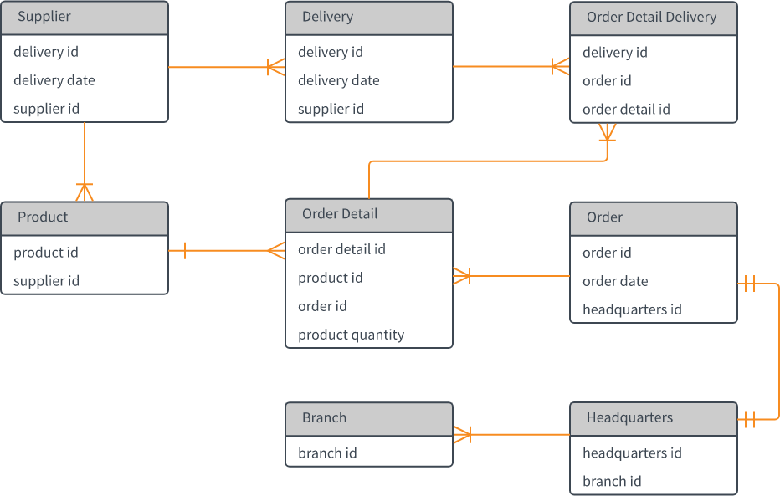

- How many foreign keys are there in the Supplier table?
A) 0
B) 3
C) 2
D) 1
Answer:D(1)

- The type of relationship between Supplier table and Product table is:
  - one to many B) many to one
C) one to one D) many to many
Answer: A(One to Many)

- The type of relationship between Order table and Headquarter table is:
  - one to many
B) many to one
C) one to one
D) many to many
Answer: C (One to One)

- Which of the following is a foreign key in Delivery table?
  - delivery id
B) supplier id
C) delivery date
D) None of them
Answer: B(Supplier ID)

- The number of foreign keys in order details is:
  - 0
B) 1
C) 3
D) 2
Answer: D(2)

- The type of relationship between Order Detail table and Product table is:
  - one to many
B) many to one
C) one to one
D) many to many
Answer: C(One to one)

- DDL statements perform operation on which of the following database objects?
  - Rows of table B) Columns of table
C) Table D) None of them
Answer: C(Tables)

- Which of the following statement is used to enter rows in a table?
  - Insert in to
B) Update
C) Enter into
D) Set Row
Answer: A(Insert in to)

Q14 and Q15 have one or more correct answer. Choose all the correct option to answer your question.

- Which of the following is/are entity constraints in SQL?
  - Duplicate B) Unique
C) Primary Key D) Null
Answer: B, C, D

- Which of the following statements is an example of semantic Constraint?
  - A blood group can contain one of the following values - A, B, AB and O.
  - A blood group can only contain characters
  - A blood group cannot have null values
  - Two or more donors can have same blood group\
Answer: A, B, C

